**SIES Graduate School of Technology**

**Department of Computer Engineering**

**Mini Project Report on**

**“Informative Website on Covid-19”**

**(AY 2020-21)**

**Group Members:**

Roll No. Name of the student

119A3013 Dhanvi Mange

119A3015 Divyalaxmi Thiruganan

119A3032 Madhuri Ramakrishnan

119A3054 Mahitha Vaidyanathan

* **Introduction:** We have created an informative website on the current situation of COVID-19.It highlights various aspects related to Corona virus such as the Symptoms, Precautions, Treatment, Modes of transmission and some general Facts. It includes interesting features such as the corona virus map which shows the live count of number of cases around the world as well as a symptom checker which enables the user to check the risk of getting infected by the virus.
* **Project Goals**: The idea behind the website is to provide necessary and important information about COVID-19 .The website helps to create awareness among the people and also tell them the necessary precautions that can be taken to avoid the virus. The website also provides a collective data of helpline numbers of all the states and union territories of India which can be used by the user in case of emergencies.
* **Problem definition:** Provides user about the general and effective information which lowers the risk of spread of fake information. The Corona virus tracker helps the user to check the statistics of the count of the cases, recoveries and deaths around the world. The Symptom checker helps the user identify COVID-19 symptoms and their risk profile.
* **Web Technologies:** The Web technologies we used were Html, Css , Bootstrap and Java Script. We used Html to give a basic layout to the website. Css and Bootstrap were used for styling the website to make it look interesting. Java Script was used for form validation as well as to make the website more interactive and user friendly.
* **Flow diagram :**

Covid-19

Modes of Transmission

Precautions

Symptoms & Treatment

Home

Facts Transmission

Basic Information regarding Covid-19 with the help of carousels, various videos from YouTube, info graphics as well as the corona virus map which displays the live count of cases around the world.

We enlisted the important symptoms that everyone must be aware of. We included another YouTube video with the help of cards which demonstrated the common symptoms of Covid-19. It also includes the symptoms a symptom checker which enables the user to check the risk of getting infected by the virus.

We incorporated the basic 8 Precautions with the help of cards and various images. We also included a video from YouTube which shows the correct way to wash your hands for 20 seconds.

We included the different modes of transmission of the virus as well as the duration that it would last on various materials which we use on a daily basis.

We included 5 different facts in a question answer format.

* **Code:**
* Form(Symptom Checker):

<!DOCTYPE html>

<html>

<meta name="viewport" content="width=device-width, initial-scale=1.0">

<link href="https://fonts.googleapis.com/css?family=Raleway" rel="stylesheet">

<title>Symptom Checker</title>

<body>

<form name="myForms"id="regForm" onsubmit="return validateForm()">

  <h1 >Symptom Checker</h1>

  <!-- One "tab" for each step in the form: -->

  <div class="tab intro">

  <h1>Hello!</h1>

  <div class="intro"><img src="Hello.JPG"></div>

 <p style="text-align: center;">You’re about to use a short, safe and anonymous health checkup. Your answers will be carefully analyzed and you’ll learn whether or not you are at a High Risk to get affected by Covid-19.</p>

</div>

  <div class="tab">

    <h1><u>Terms of Service:</u></h1>

    <img src="T&C.jpg" alt="">

    <p>Before using the symptom checker, please read Terms of Service. <strong>Remember that:</strong>

    <ul>

      <li style="font-size: 20px;"><strong>The is not a diagnosis.</strong> Checkup is for informational purposes and is not a qualified medical opinion.</li><br>

      <li style="font-size: 20px;"><strong>Do not use in emergencies.</strong> In case of health emergency, call the helpline numbers provided in the webpage immediately.</li><br>

      <li style="font-size: 20px;"><strong>Your data is safe.</strong> Information that you provide is anonymous , not saved anywhere nor shared with anyone.</li><br>

      <p style="font-size: 20px;"><input type="checkbox" class="large" id="check1" checked onclick="Check()">I read & accept the Terms of Services</input><br></p>

    </p></ul>

  </div>

  <div class="tab"><h4>Name:</h4>

    <div class="try"><p><input placeholder="Enter Your name" oninput="this.className = ''" name="fname" required></p>

    </div>

    <h4>What is your gender?</h4>

    <p>

    <select>

<option></option>

<option>Male</option>

<option>Female</option>

<option>Others</option>

</select>

</p>

   <div class="try"><h4>Please Select your Age in Years</h4>

   <p><select>

    <option></option>

    <option>0-25</option>

    <option>25-50</option>

    <option>50-75</option>

    <option>75-100</option>

    </select></p>

   </div>

  </div>

  <div class="tab"><h4>Do you currently have any of these health conditions?</h4>

  <div class="ch" >

    <p>

       <input type="checkbox" class="large" id="a1">No existing conditions</input><br>

       <input type="checkbox" class="large" id="a2">Asthama</input><br>

       <input type="checkbox" class="large" id="a3" >Cancer</input><br>

       <input type="checkbox" class="large" id="a4">Chronic lung disease(COPD)</input><br>

       <input type="checkbox" class="large" id="a5">Diabetes</input><br>

       <input type="checkbox" class="large" id="a6">Hypertension</input><br>

       <input type="checkbox" class="large" id="a7">Heart disease</input></p>

       </div>

  </div>

  <div class="tab"><h4>Have you or someone in your family staying with you come in close contact with a laboratory confirmed COVID-19 patient in the last 14 days?</h4>

    <p><select>

<option></option>

<option  id="y1">Yes</option>

<option id="n1">No</option>

</select></p>

<h4>Have you or someone in your family staying with you attended a large gathering/ in a migration centre in the last 14 days?</h4>

<p><select>

<option></option>

<option id="y2">Yes</option>

<option id="n2">No</option>

</select></p>

<h4>Are you or any of the family member staying with you currently working for essential services in public exposed places(such as hospitals, retail outlets, delivery services)?</h4>

<p><select>

<option></option>

<option id="y3">Yes</option>

<option id="n3">No</option>

</select></p>

  </div>

  <div class="tab"><h4>Are you having one or more of the following symptoms?</h4>

    <div class="ch">

    <p>

    <input type="checkbox" class="large" id="b1">None</input><br>

    <input type="checkbox" class="large" id="b2">Fever</input><br>

       <input type="checkbox" class="large" id="b3">Dry Cough</input><br>

       <input type="checkbox" class="large" id="b4">Feeling shortness of breadth</input><br>

       <input type="checkbox" class="large" id="b5">Sore throat</input><br>

       <input type="checkbox" class="large" id="b6">Hoarseness in voice</input><br>

       <input type="checkbox" class="large" id="b7">Headache</input><br>

       <input type="checkbox" class="large" id="b8">Running Nose</input><br>

       <input type="checkbox" class="large" id="b9">Loss of Smell</input></p>

       <button type="button" id="check" onclick="my()">Check</button>

       </div>

  </div>

  <div style="overflow:auto;">

    <div style="float:right;">

      <button type="button" id="prevBtn" onclick="nextPrev(-1)">Previous</button>

      <button type="button" id="nextBtn" onclick="nextPrev(1)" >Next</button>

    </div>

  </div>

  <div style="text-align:center;margin-top:40px;">

    <span class="step"></span>

    <span class="step"></span>

    <span class="step"></span>

    <span class="step"></span>

    <span class="step"></span>

    <span class="step"></span>

  </div>

</form>

</body>

</html>

**SnapShot:**

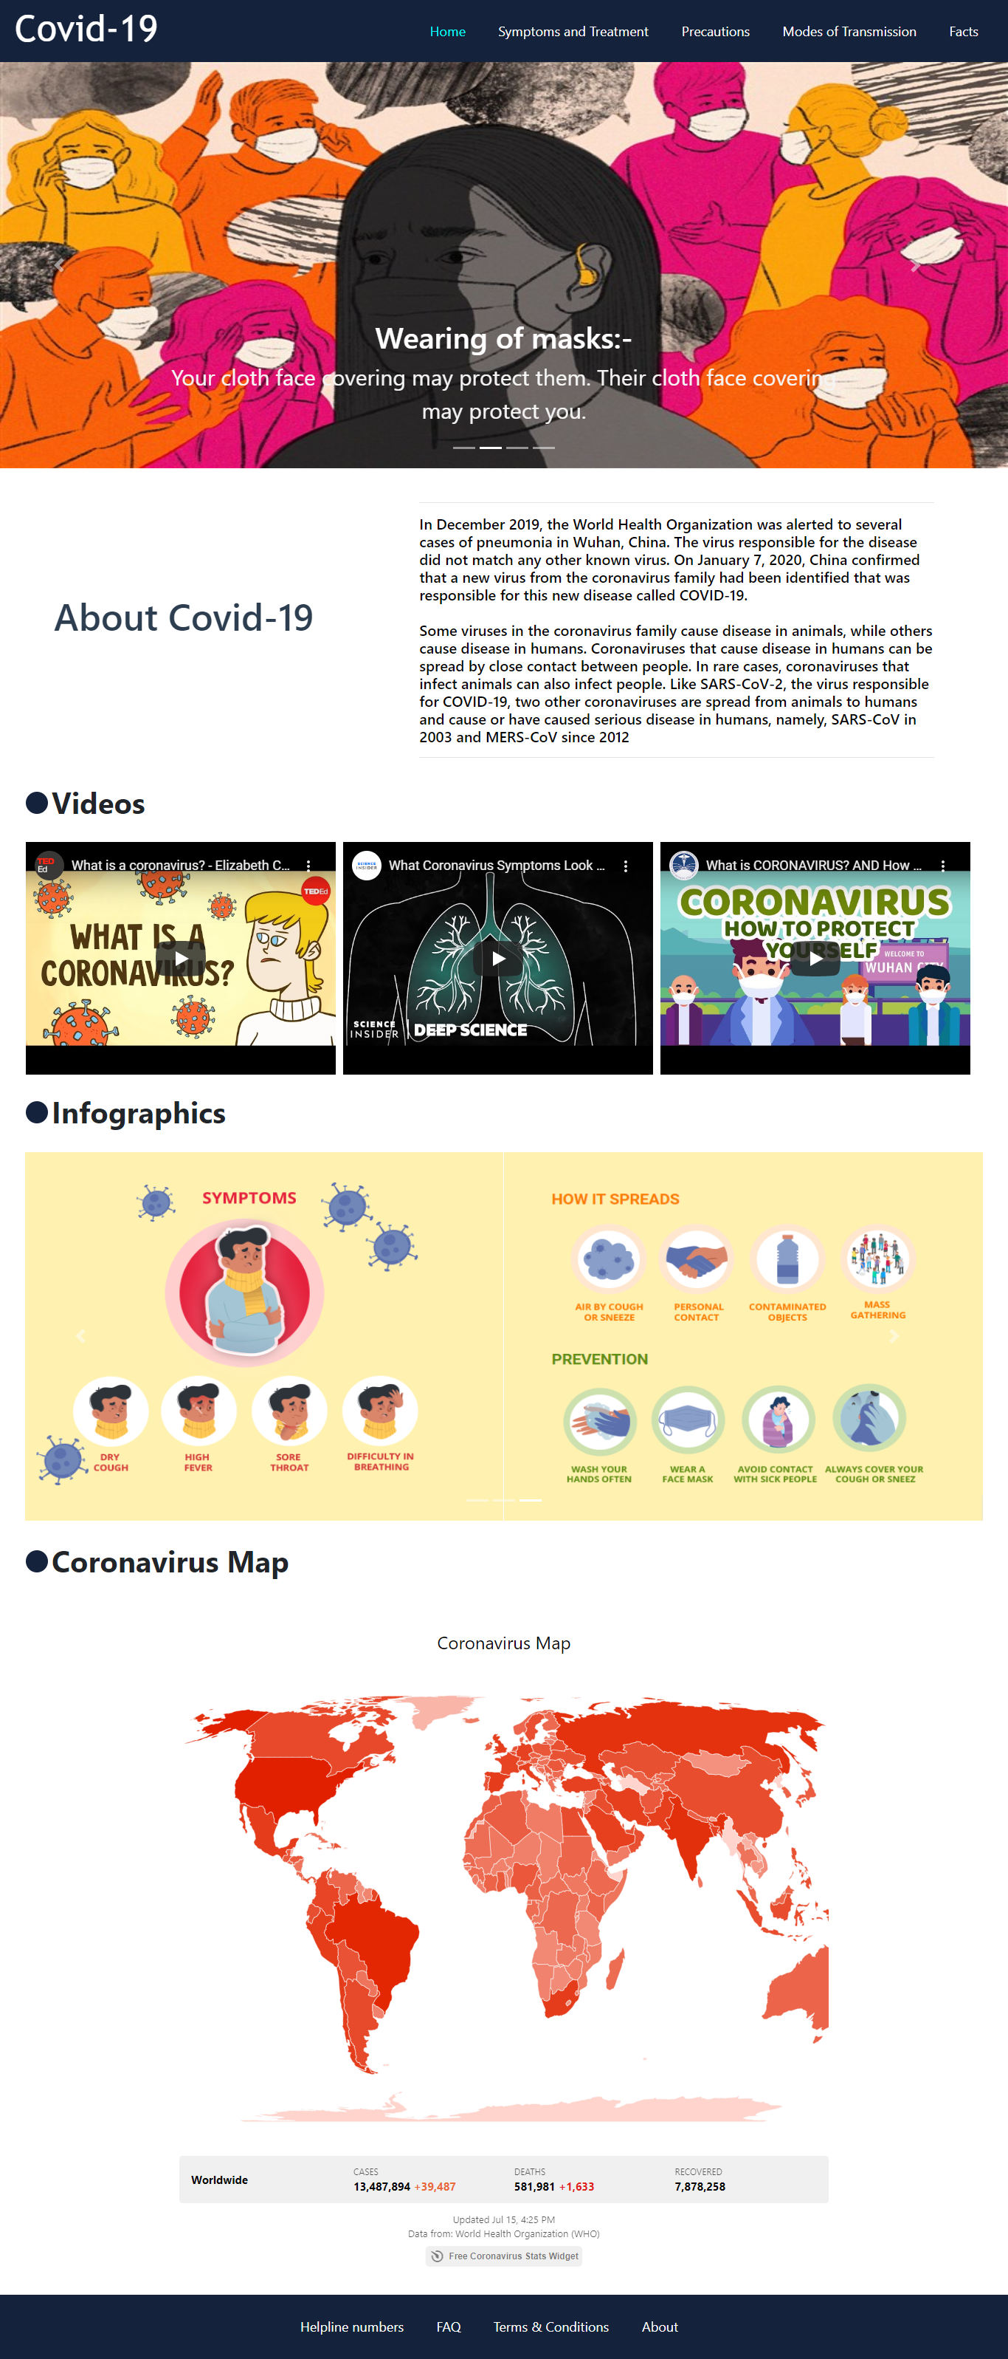

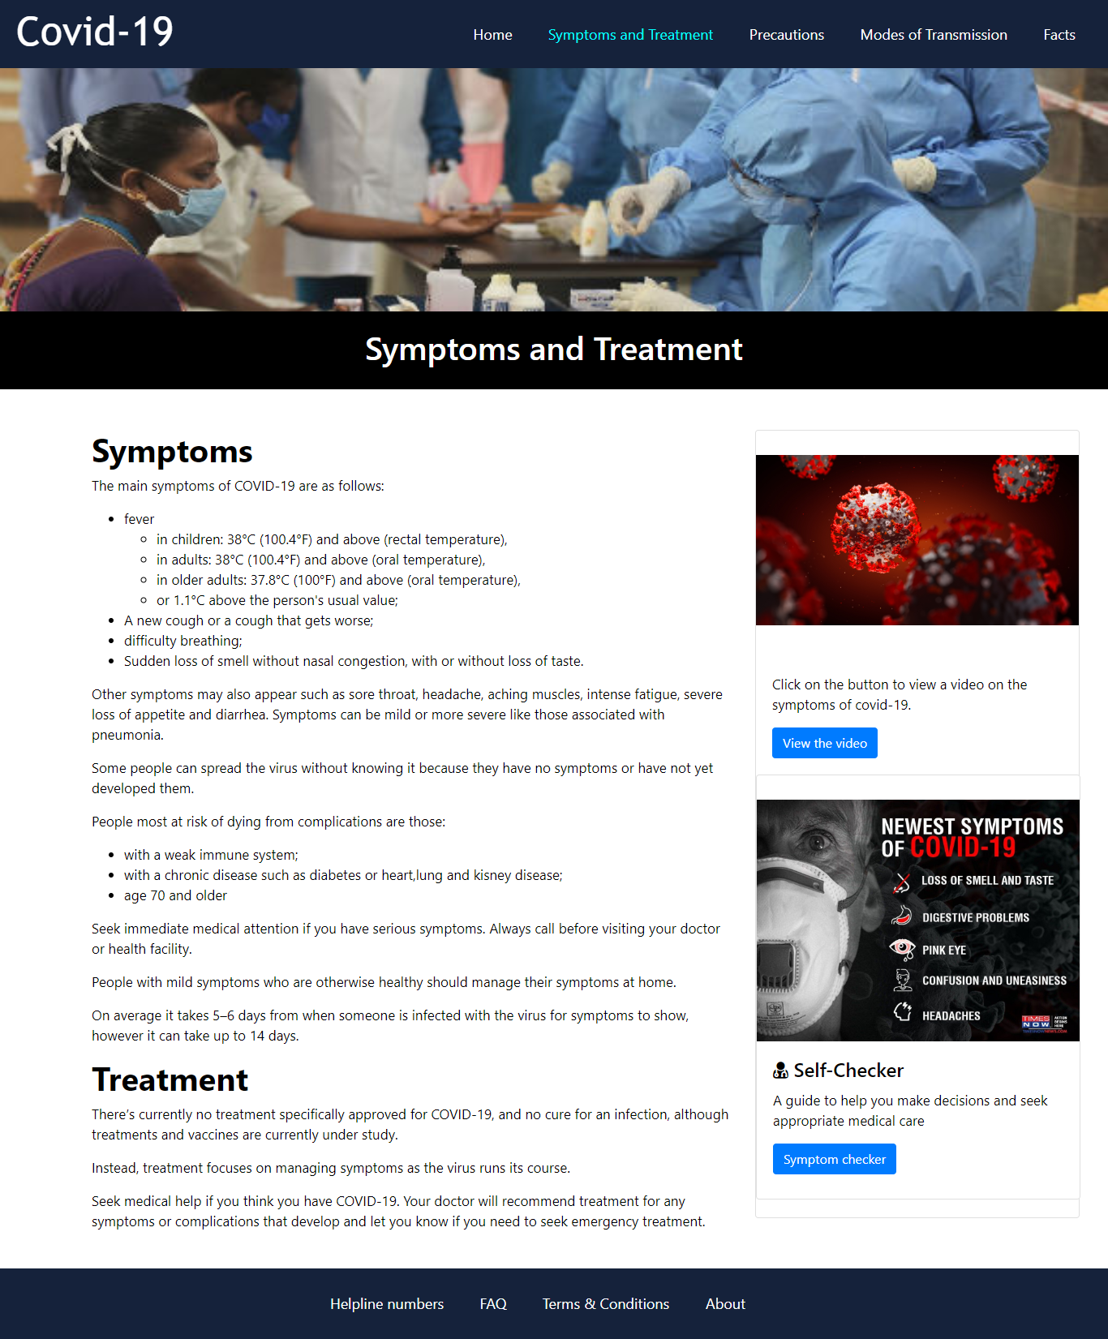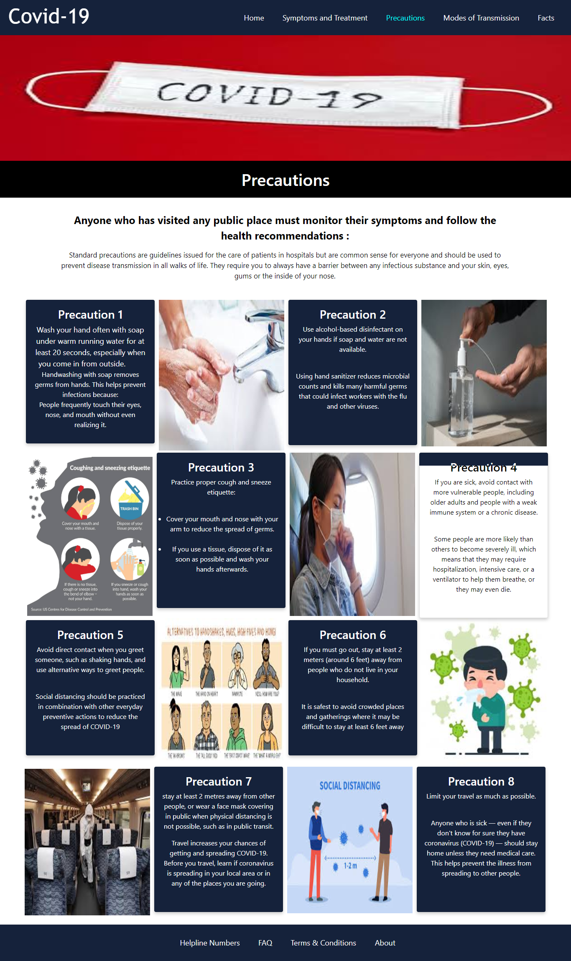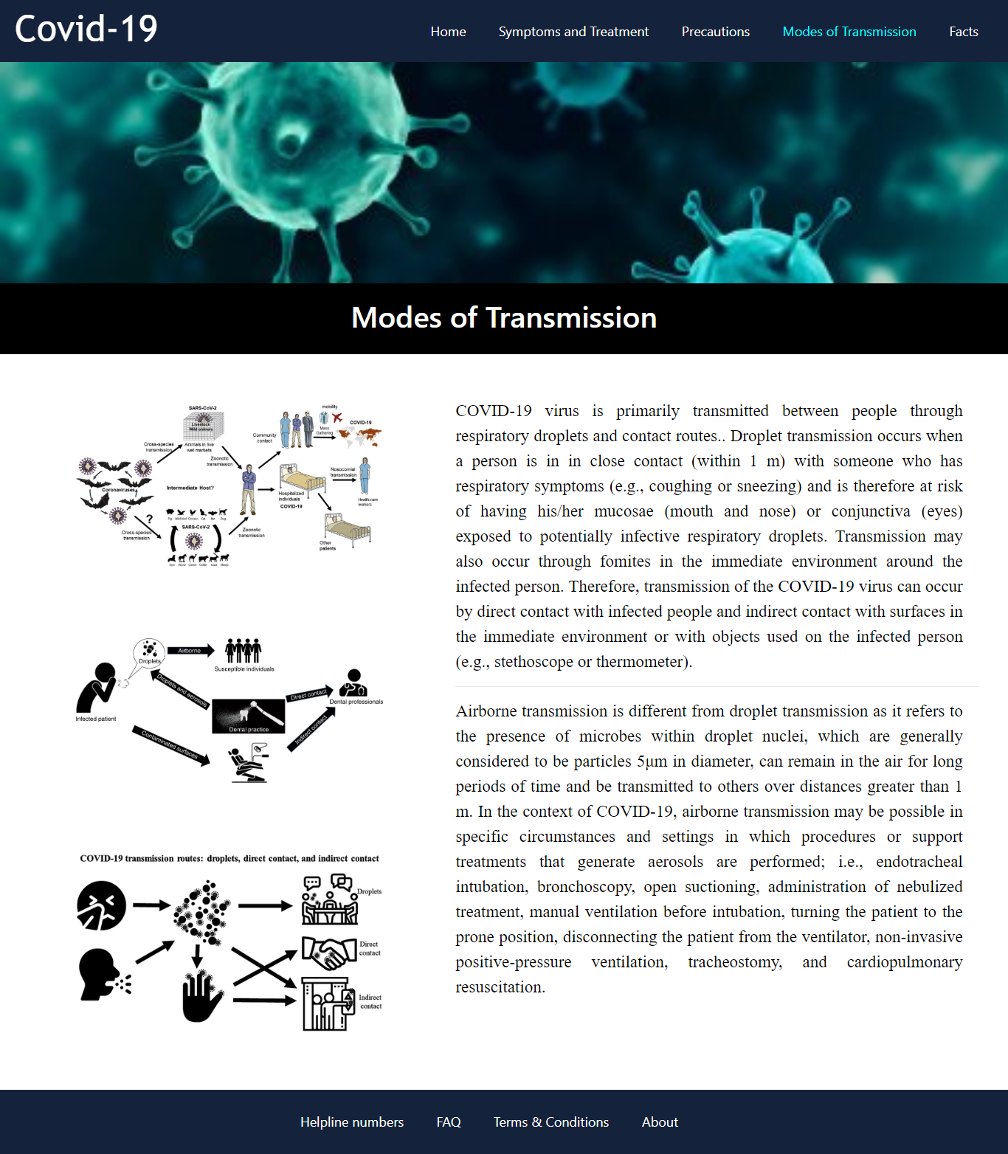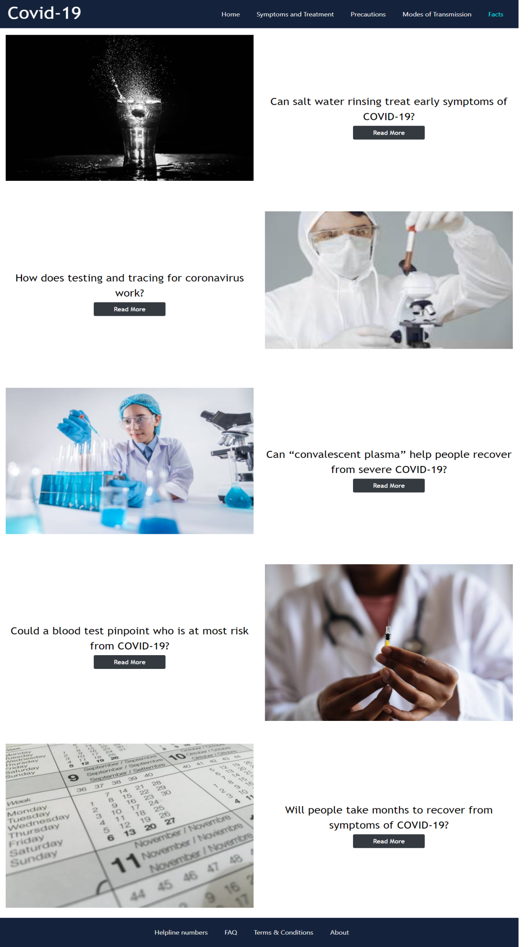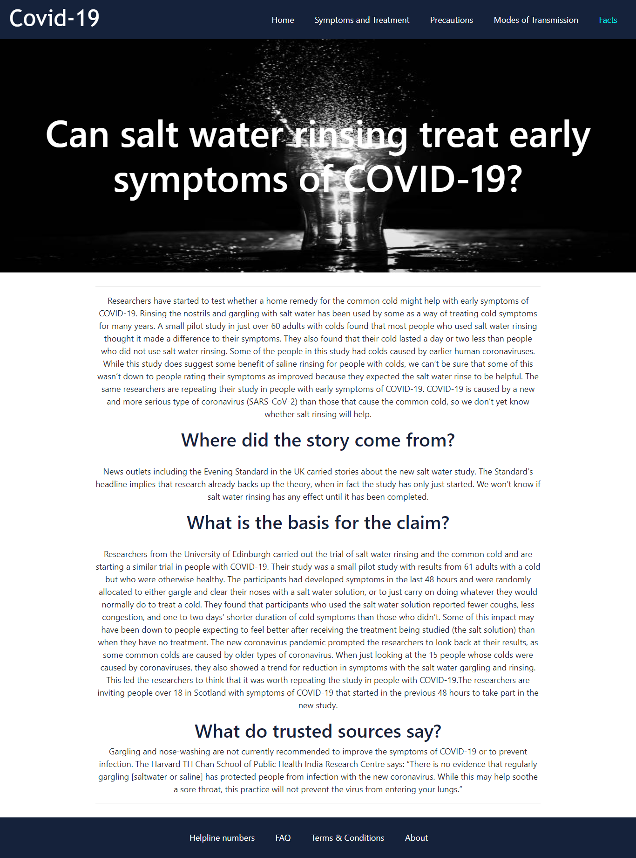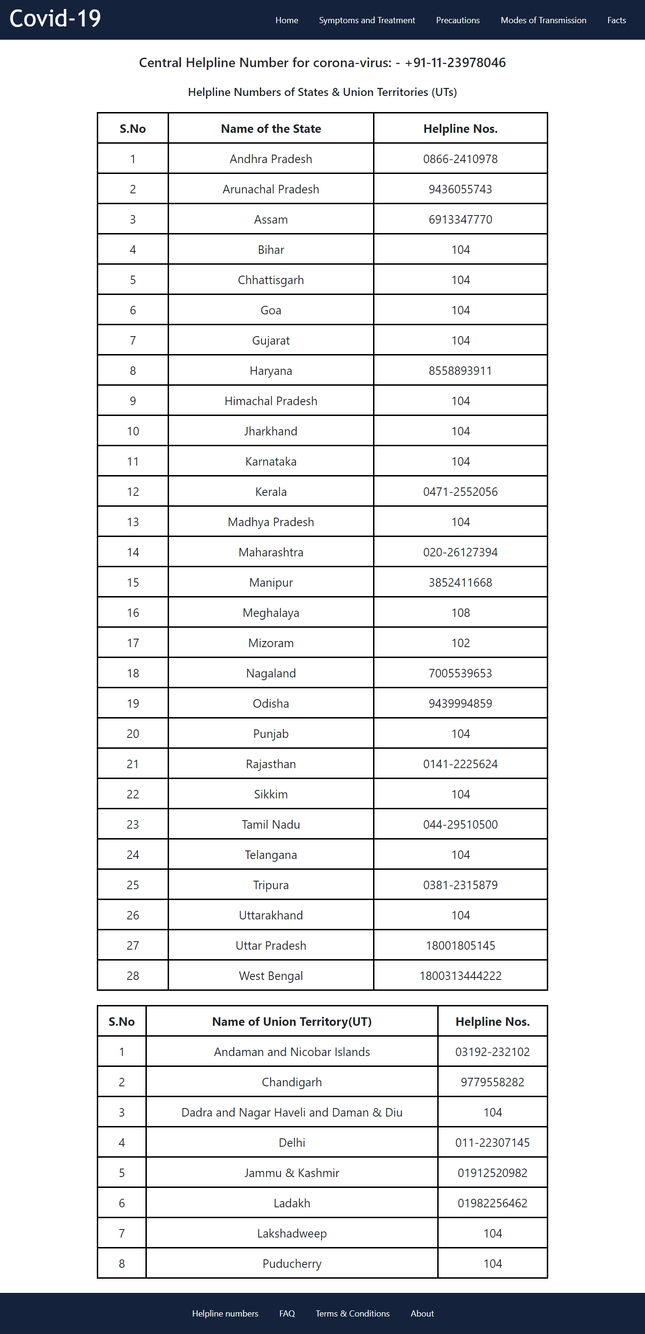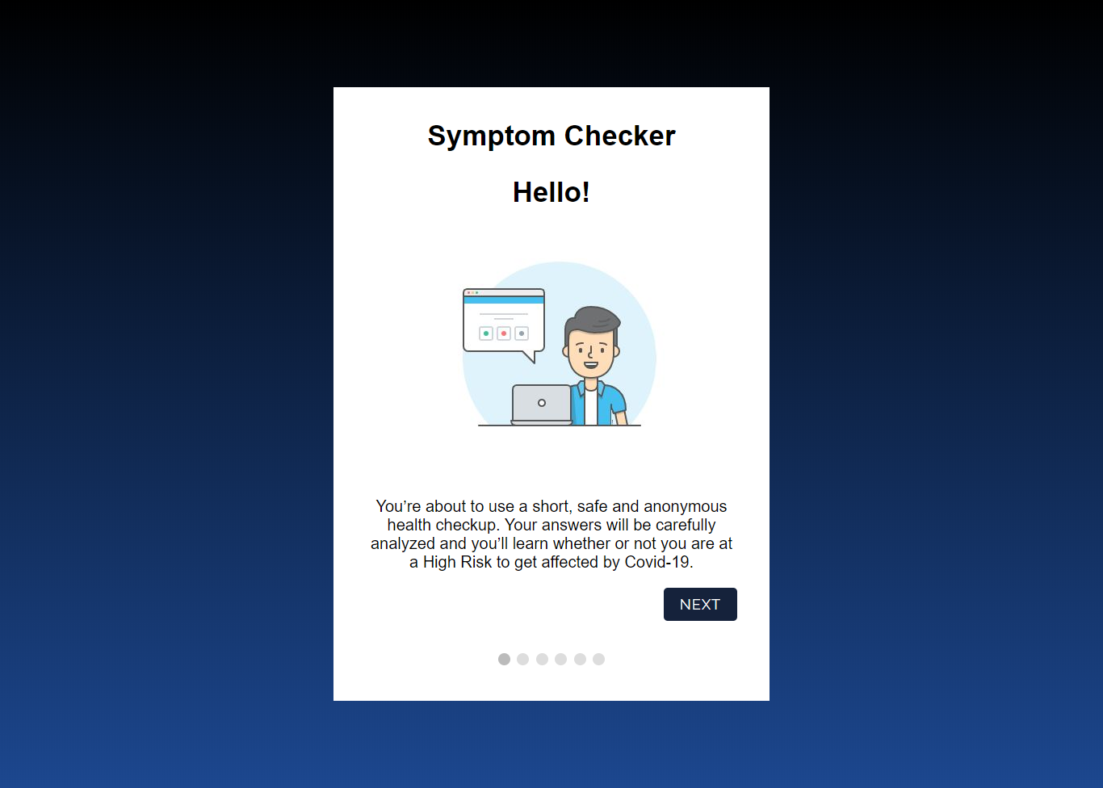

* **Conclusion:** This website will be useful for users to analyze the COVID-19 situation. Thus we took an initiative and created this website to spread awareness as a social cause. It answers the ongoing myths about the spread and precautionary measures to be taken during this pandemic situation.
* **References:** We took references from the following websites:
* <https://www.who.int/>
* <https://www.covid-19facts.com/>
* <https://www.mygov.in/covid-19>
* <https://www.w3schools.com/bootstrap4/>
* <https://elfsight.com/>